**FEATURE DRIVEN DEVELOPMENT**

**FDD** stands for **Feature-Driven Development**. It is an agile iterative and incremental model that focuses on progressing the features of the developing software. The main motive os feature-driven development is to provide timely updated and working software to the client. In FDD, reporting and progress tracking is necessary at all levels.

**FDD Lifecycle**

* Build overall model
* Build feature list
* Plan by feature
* Design by feature
* Build by feature

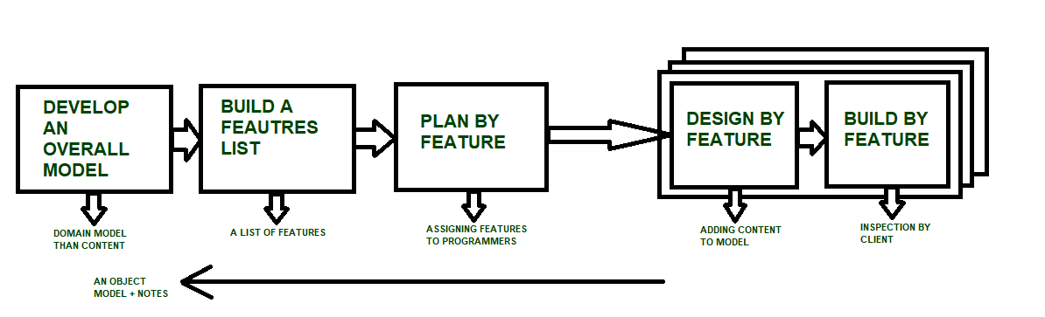

**Characteristics of FDD**

* **Short iterative:** FDD lifecycle works in simple and short iterations to efficiently finish the work on time and gives good pace for large projects.
* **Customer focused:** This agile practice is totally based on inspection of each feature by client and then pushed to main build code.
* **Structured and feature focused:** Initial activities in lifecycle builds the domain model and features list in the beginning of timeline and more than 70% of efforts are given to last 2 activities.
* **Frequent releases:** Feature-driven development provides continuous releases of features in the software and retaining continuous success of the project.

**Advantages of FDD**

* Reporting at all levels leads to easier progress tracking.
* FDD provides continuous success for larger size of teams and projects.
* Reduction in risks is observed as whole model and design is build in smaller segments.
* FDD provides greater accuracy in cost estimation of the project due to feature segmentation.

**Disadvantages of FDD**

* This agile practice is not good for smaller projects.
* There is high dependency on lead programmers, designers and mentors.
* There is lack of documentation which can create an issue afterwards.